Dear Hanh,
The old APE system interface needs some modifications to cater for new product and job type.
Job details screen:
- Ship to Party information during creation of Job Detail screen. There is to meet our Customs requirement that GST will be incurred for local delivery (ship to party) even though the customer (sold to party) is from overseas.
- Customer code will be 3 characters → XYZ

Job Sheet screen:
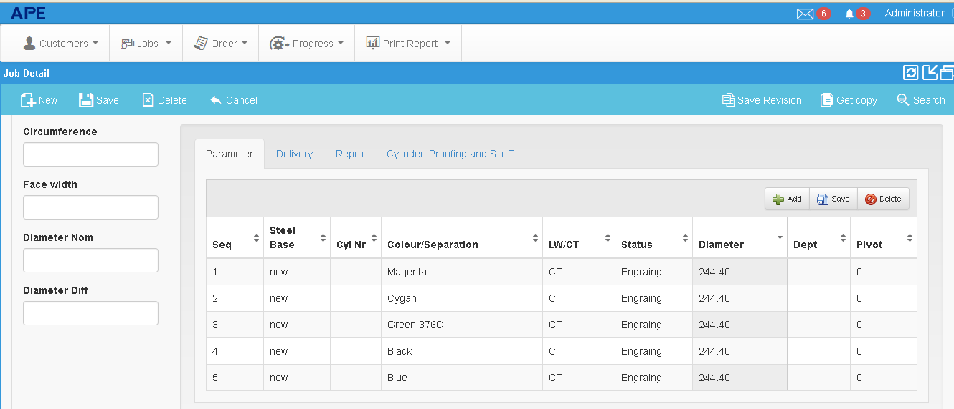
1. Status field - pull down list:
- Common
- Matching
- Mechanical Engraving (EMG)
- Laser Etching (DLE)
- Laser Engraving (DLS)
- Embossing (EMB)
- De/rechrome
2. LW/CT Field→ this is for price calculation for Mechanical engraving only. To cater for other types of job, we can replace the title to “Pricing”. In the new system, we need to have additional option i.e.
- LW
- CT
- Piece (This is for Tobacco job where the price is fixed per piece basis)
- None (to cater for de/rechrome job)
Confirm Order screen (OC/DO/Invoice)
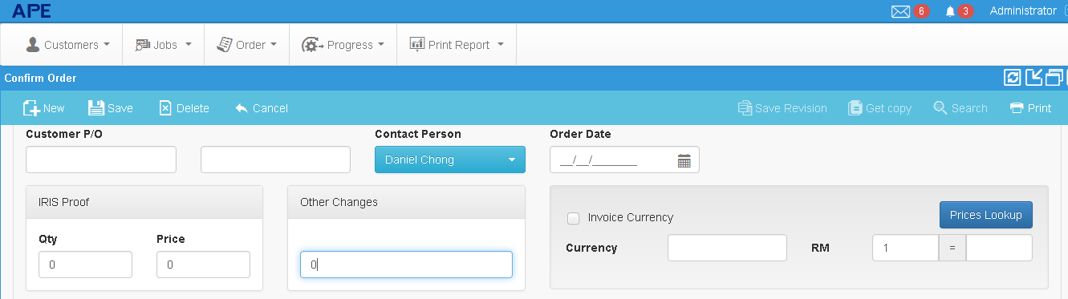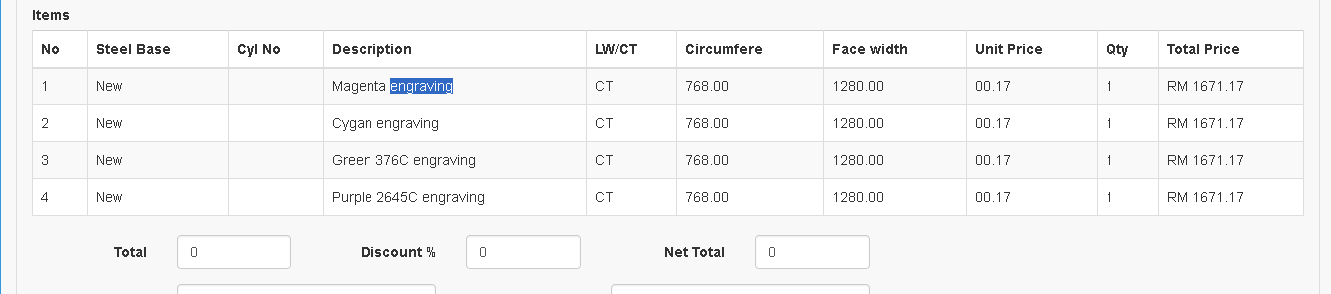
- GST Tax code and Tax rate column by line item in the "Confirm Order" screen
- Status column in the item screen – This information comes from the input screen in Job Details.
- We need to remove the Iris Proof and Other charges field and replace it with line item input screen which we can insert GST tax code and tax rate and calculate the price
Example of Other charges (free text):

→Transport
→Packing
→Digital Proofing
→Combi & Stepped film
→Gears
→Etc.
Invoice Screen:
1. New number structure for Invoice number by using running no. format. We do not want to use same no. for invoice job order. There will be a case of multiple orders in one invoice (combine shipment).

Quotation Screen.
This screed is obsolete since it can cater for Mechanical Engraving job only.
I need to discuss with Mr. Liong on what information needed here.
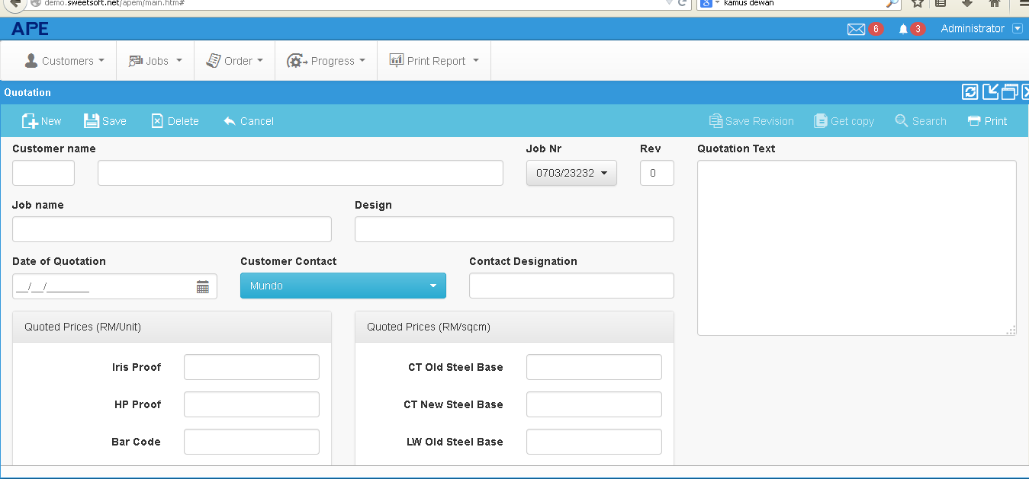

New cylinder order screen:
- PO number: running number format
- Qty and Purchase price column.
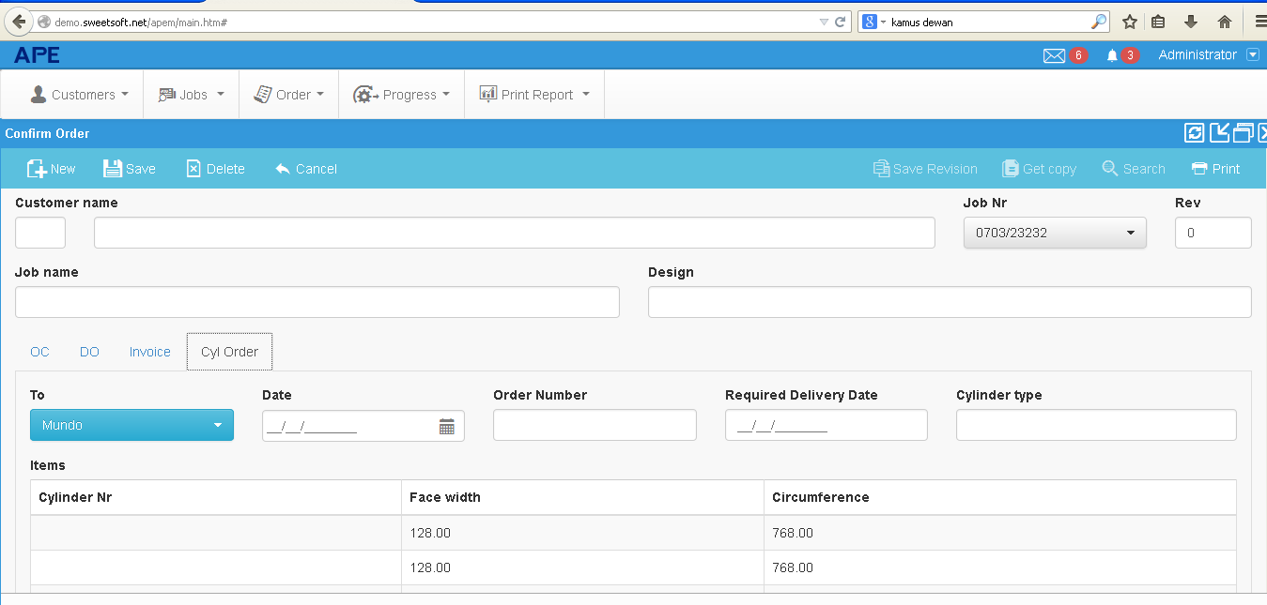

Other type of Job not related to Engraving
- We need to have an additional Job entry screen which not related to engraving job.
- It will be in multiple currency
Format:
No Work Order Number: Product ID. Description. Value GST Code GST Rate Total Value

